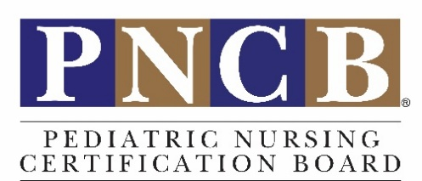

Interview a Local Pediatric Nursing Professional

What: Invite local pediatric nursing professionals in a variety of roles (RN/PNP/CNS) to be interviewed. Seek out nurses in a variety of settings who provide different types of care for pediatric populations.

Examples include but are not limited to: schools, public health centers, juvenile detention centers, children's hospitals, and community hospitals. Seek out a variety of units in hospitals, such as med-surg, emergency, oncology, critical care, subspecialty clinics, etc. For contacts beyond who you or your faculty already know, consider contacting local chapters of pediatric nurse associations.

Why: You'll explore career paths, challenges, and rewards of specific roles.

Special Note: Consider sharing your questions ahead of time so your guest feels prepared.

- Where are you employed, and what is your position?
- Tell us about your nursing career and what other pediatric nursing roles have you held?
- What education or experience did you need to achieve your role?
- Why did you choose pediatric nursing?
- What age ranges do you see?
- Take us through a typical day or week.
- What do you do to stay current in practice, such as specific conferences, journals, or continuing education?
- Tell us about the other healthcare team members or non-healthcare staff with whom you collaborate.
- How do you promote family-centered care?
- What is your favorite thing about your job?
- What are your biggest challenges?
- Where do you see yourself in five years? In ten years?
- Has technology impacted your work significantly in the past 12 months?
- What do you feel is the biggest health issue facing children today? What do you predict will be the biggest issue ten years from now?
- Who were (or are) your mentors and why?
- What tips can you share about finding a mentor?
- What was your favorite class in nursing school?
- What are some things you wished you'd learning in nursing school?
- How can students get the most out of their pediatric clinical rotations?
- How do you manage stress and practice self-care?
- What advice can you share with students interested in your role?

